1. Team Members’ Names & Student IDs

* Andy Sim S10194032
* Chua Kai Ling S10205229
* Damien Tan S10206197
* Javier Oon S10204445
* Ernest Tan S10204577

1. Description of App

Storm Net is a Weather App that is currently based in Singapore. It aims to be able to provide users with weather information of specific regions/areas in Singapore and also other countries in the future. The main goal of the app is to roll out a brand new channel for users who often check the past, current and future weather activities. The app promises to provide users with a more convenient, accurate and effective experience in checking for information related to weather as compared to other similar platforms.

Meanwhile, look forward to our new versions. We will be working to implement more new features such as notifications, tracking of location, in depth weather information, visualization, city finder, etc so as to enhance users’ experience.

1. Roles and Contributions of Each Member

Andy: Layout of Feature 2, Feature 2, Slides

Kai Ling: Functionalities of Buttons (between 2 features), Feature 2, Slides, Functionality Diagrams

Damien (Upload the App): Feature 1 (Toast Function, Weather Data, Loopj Function), Troubleshooting

Javier: Users Guide, Slides

Ernest (Leader): GitHub Layout of Feature 1, Feature 1 (Display of Weather Information), Troubleshooting

1. All relevant appendices (diagrams, screenshots, user guides)

Diagrams

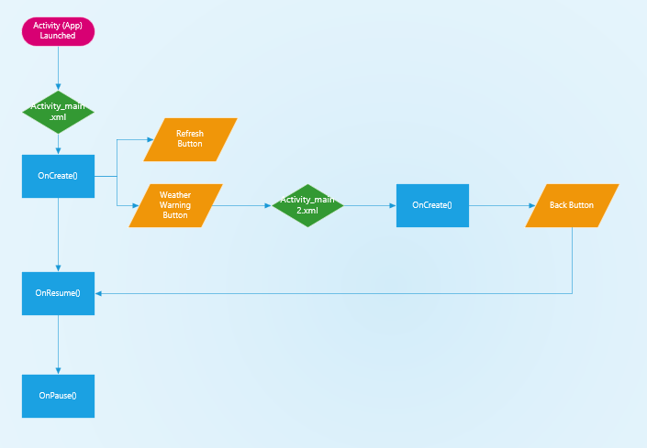

User Guides

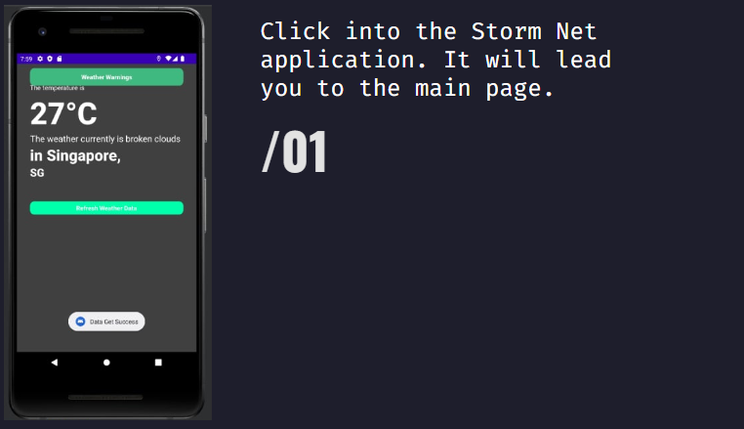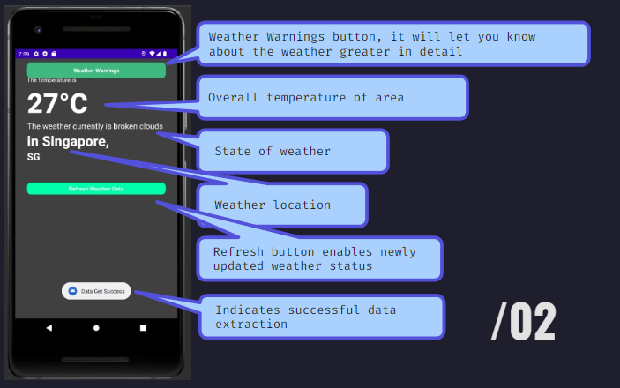

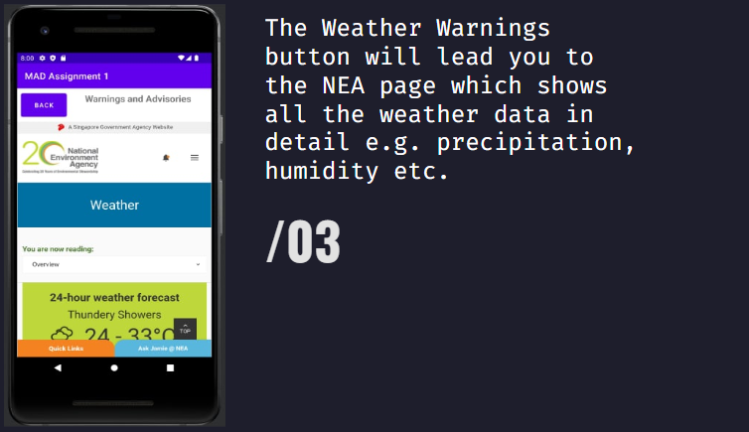g